Project

Name of project: CASSANDRA - An IoT system for long-term monitoring and alerting vital heart problems

Competition Track: Planet NI

Contact Information

Name:  Phạm Khôi Nguyên

School:  International University – Vietnam National University (VNU)

Department:  Biomedical Engineering   Year:  2013 - 2017

Email: phamkhoinguyen1995@gmail.com       Mobile Phone: + (84) 914 118 896

Mailing Address:  Room 34, Binh Phu Apartment, Ward 10, District 6, Ho Chi Minh City

Project Adviser

Name:  Dr. Lê Quốc Trung

Title:  Lecturer of University                    Organization: International University – VNU

Email: lequoctrung@gmail.com             Mobile phone: + (84) 915 538 938

Team Members

1. Name:  Cù Gia Huy

Email:  [huycu17@gmail.com](mailto:huycu17@gmail.com)

Mobile phone:  + (84) 969 074 690

1. Name:  Nguyễn Thanh Trúc

Email:  [ngthanhtruc.iuetv@gmail.com](mailto:ngthanhtruc.iuetv@gmail.com)

Mobile phone:  + (84) 166 262 7929

**Project Paper**

**1. Abstract**

CASSANDRA is an Internet of Things system aiming to ease the current condition of the sudden heart attack around the world. Our project strives to provide home care solution to individuals who are at high risk of CAD. The final outcome of our project is a complete system that could be able to perform long-term monitoring, streaming data to hospitals and alerting vital cardiac arrest. Three main components of the project are: a small sensor that measures the Electrocardiogram (ECG) signal, a mobile application that receives, stores and streams data and a hospital website for doctors to analyze and provide medical prescription in real-time. The team hopes to bring forward the era of home care, where the patient can get instantaneous and reliable health checkup without going directly to the hospitals.

**Project Introduction**

**⮚ Literature review about cardiovascular disease**

For many decades, cardiovascular disease (CAD) is the leading cause of death during patients’ hospitalization across the globe. As reported by the World Health Organization (WHO), there was about 17.3 million people around the world died from CAD in 2008, representing 30% of all total cases of death globally. This number is expected to grow up to 23 million by 2030. Vietnam is also one the most susceptible countries to CAD. The World Heart Federation (WHF) estimates that the incidence of CAD in Vietnam in 2017 may reach 20%, ranking 4th in the world.

**⮚ What is the cardiovascular disease?**

Cardiovascular disease, also known as Heart Attack, is a disease caused by insufficiency of blood supply to the heart’s tissue. This is caused by the formation of fat and cholesterol layer beneath the vessel’s inner wall that obstructs blood flow. Shortage of blood will eventually lead to tissue’s death, causing a sudden cardiac arrest.

Treatments for CAD: Stenting and Coronary Bypass Graft, for example, are extremely expensive. Therefore, the most effective therapy is diagnosing and treating the disease before it could actually happen, which is also known as preventive medicine. Elaborately, this type of treatment focuses on detecting the disease at an early stage, so that appropriate medical attention could be given to avoid disease’s progression. Some of these powerful medical diagnosis techniques include: Cardiac MRI, CT Angiography and Echocardiography. These techniques yield considerable advantages: high accuracy, clear image resolution and provide valuable additional information about the disease. However, these types of diagnosis are not suitable for home care solution and also not available in many rural areas of Vietnam dues to their high cost, complicated clinical procedures and cumbersome devices. Not only that, a technician who is qualified enough to perform the diagnosis are not always available. Fortunately, however, there is another technique that is also reliable, much more affordable in term of cost, suitable for performing long-term monitoring at home and has been widely applied to diagnose CAD: the Electrocardiogram signal.

**⮚ The Electrocardiogram signal**

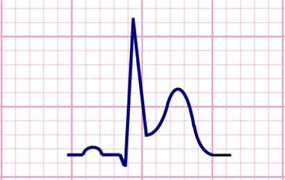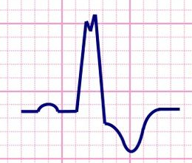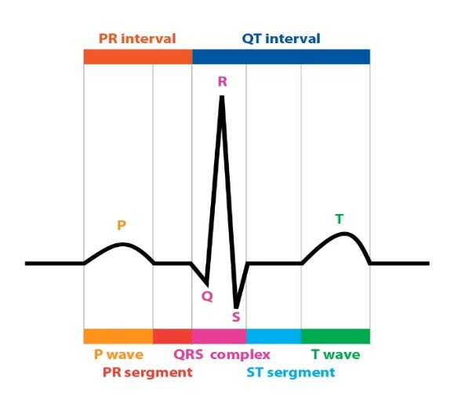ECG, or Electrocardiogram, measures the electrical activity of the heart during each consecutive heart beats. The current clinical diagnostic technique using ECG analyses the shape of the waveform and calculate the magnitude, energy and entropy of the signal to deliver valuable information about the heart. For example, by focusing on some specific segments of the signal: P wave, T wave, the presence of Q wave and ST segment, detection of myocardial infarction, cardiac arrest and arrhythmia can be achieved.

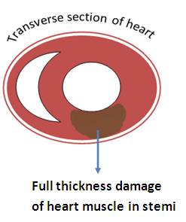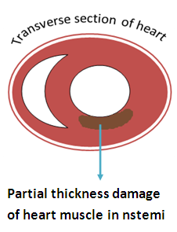

**Figure 1**: from left to right are a normal ECG waveform versus two altered ECG waveforms that correspond to different types of cardiovascular problem

ECG measurement has been used as a standard procedure for approving patients to the Heart Disease Department in almost hospitals around the world because of its low expense, fast and reliable. In addition to that, technical aspects of the signal also elevate ECG as a wonderful approach to develop a small, light-weight device that is suitable for home care solution. To illustrate this point, many famous chipset companies such as Texas Instrument and National Instrument, is currently providing small, affordable ECG modules with very good signal quality. Most importantly, the greatest interesting feature of this signal remains in its medical prognostic value. The use of ECG to forecast the occurrence of heart attack is still an uncultured field but yet extremely profitable if it was discovered. Imagine of a software that could predict in advance the occurrence of sudden cardiac arrest, alarming doctors to make an immediate response that could ultimately save patients’ lives.

**⮚ The birth of an innovative system**

As previously elaborated, using ECG as an approach to solve cardiovascular problems yields great advantages in terms of affordable cost, suitability for home care solution, signal reliability and its potential prognostic value. Understanding these benefits, diverse devices had already been introduced to the market, each one of them comes with both pros and cons that will be discussed below.

* **Analysis of the current devices**

The most famous device which is widely equipped in hospitals and clinics is the Alice5 machine. This device is capable of obtaining up to 15 leads of ECG signal, each lead describes the electrical variation of the heart from a different angle, comparing to an average of 12 leads from other instruments and comes with extreme signal resolution and accuracy (up to 1,000Hz of sampling rate). However, problems associated are expensive cost and cumbersome design that makes it unsuitable for home care solution, in addition to the old paper-printed result that could only last for a couple of minutes.

Next type is the Holter monitor. This type of device also accomplishes high-resolution data with great accuracy and could operate up to 1 day long of continuous measurement. Although Holter monitor is more affordable and suitable for home care, patients using this type of device still experience inconvenience due to its immobility. Data is also stored locally, and patients have to hand it to their doctors after measuring.

Finally, the last generation is the portable ECG device. This model sacrifices part of signal quality in order to achieve its small shape, effective cost and mobility that is currently the best choice for home care solution. However, most of them lost the ability to perform long-term measuring due to the shortage of battery and memory. Some of them come with the ability to measure up to 1 day long, but their memory can only store limited records, not to mention that these records are isolated and the user has to hand the result to doctor after measurement.

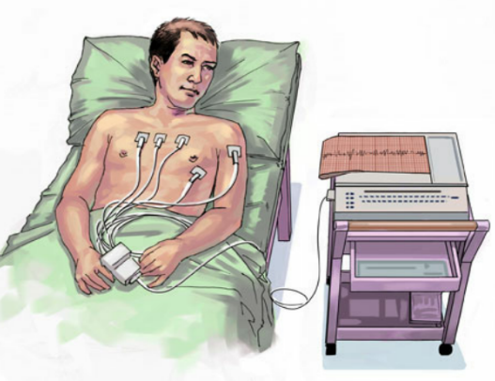 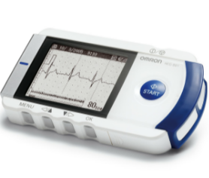 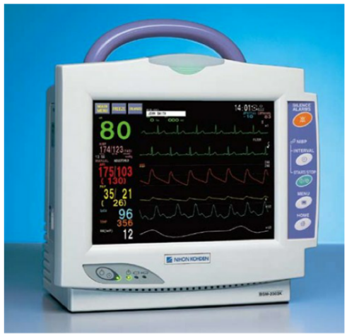

**Figure 2**: from left to right are a table ECG machine, a portable ECG device and a Holter monitor

* **Our proposed system**

Understanding these limits in the current devices, we try to approach the problem using the recently emerging technology: Internet of Things.

* **Briefly about the Internet of Things**

The Internet of Things (IoT) is defined as the infrastructure of information, where diverse kinds of physical device are connected within a network that greatly enhances the ability to exchange data. This characteristic, therefore, will bring forward and breathe life to the era of Artificial Intelligent and Automation in the field of medical diagnosis since the device now can “learn by experience”. The trend of creating IoT systems is growing fast across the globe, where numerous startups emerge to meet the increasing demand for this type of innovative device.

* **The innovation within our product**

Using the available small ECG sensors, our project aims to create a wearable ECG diagnosis device, integrating it with the IoT technology to perform real-time data transmission. Our device will be designed to be cost effective without scarifying substantial amount of signal quality. After researching, we choose to minimalize our product to only contain a high-quality ECG sensor, a Bluetooth 4.0 Low Energy and a signal pre-processing board powered with a small, energy efficient battery that allows up to 2 days of continuous measurement. Unlike many other products presented in the market, our device consists of no screen, no data storage and no central processing unit that greatly cut off the price. The device, on the other hand, can communicate with user‘s smartphone via the integrated Bluetooth LE module, therefore it could harness the beautiful, high resolution screen and powerful central processing unit that is available in many modern smartphones. Additionally, smartphone is the solution to memory shortage (by using its local storage or cloud drive) and also can serve as a communication tool that transmits data to hospital across the internet or alarm patients via SMS and phone calls. These are characteristics that make our product standout from other devices currently sold in the market.

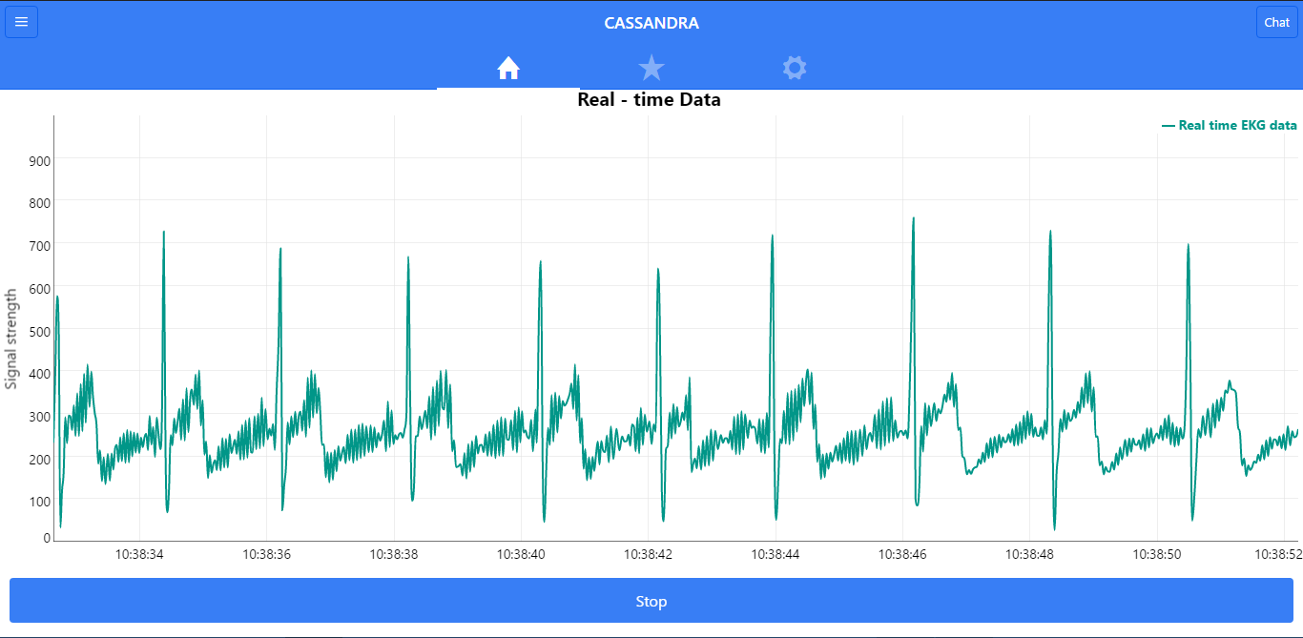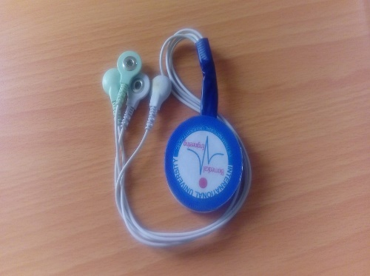

**Figure 3**: our ECG device and doctor’s website

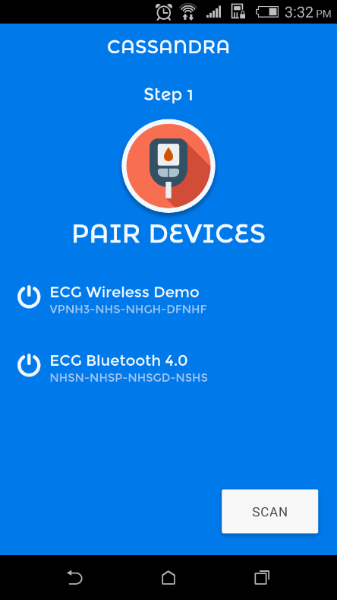**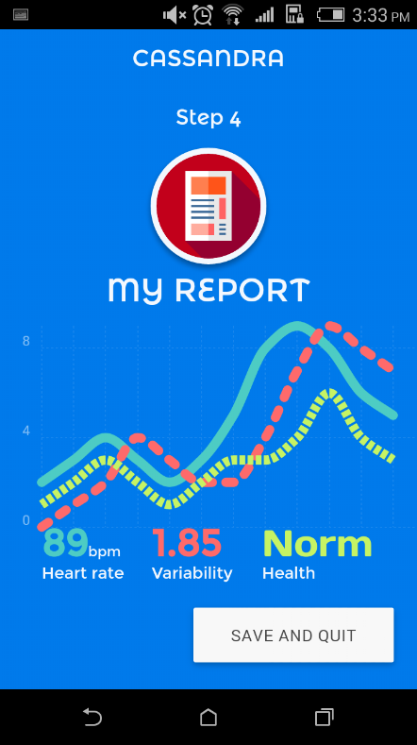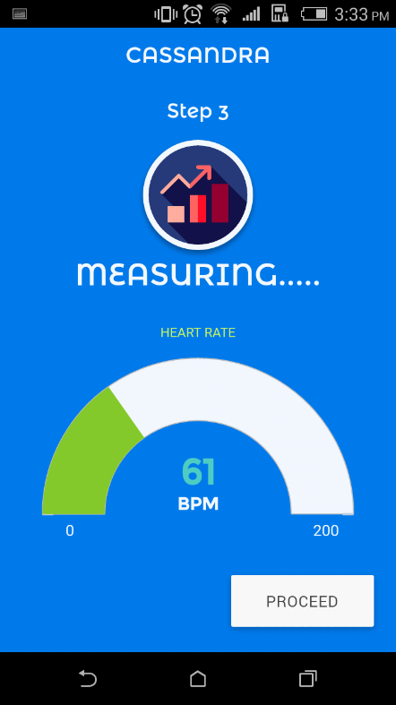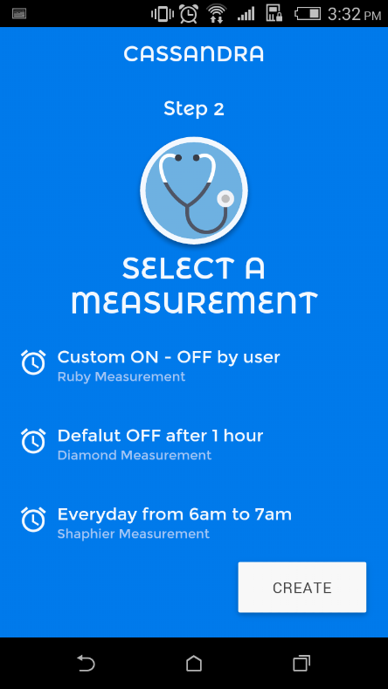Figure 4**: In order to use our application, user has to pair the smartphone with our ECG device, select a measurement type, complete the measuring process and then save the report to doctor

Not only that, because our solution focuses on preventive medicine, patients with the high risk of CAD are required to take daily measurement even though there are no clinical symptoms. The result of this activity is beneficial. It will not only give rise to an awareness of personal fitness, but also generate a unique ECG databank that is crucial for researchers and scientists to conduct further studies about the diagnostic value of ECG. Access to this databank will eventually help scientists give birth to a software that could predict in advance the occurrence of CAD, therefore could save the lives of million people died from sudden cardiac arrest every years.

**⮚ How we will use our NI package**

When it comes to product simulation and prototyping, National Instrument (NI) LabVIEW comes directly in mind. The Biomedical Engineering department, International University - VNU collaborates closely with NI to bring modern kits and software into the education syllabus. Therefore, we have an opportunity to interact with NI technology from an early age and within 3+ years learning engineering courses, we have efficient knowledge and experience prototyping products using NI software and development kit. These activities include testing product’s functionality using NI development kit and developing biomedical software using NI LabVIEW. Up until now NI is one of the best choices for engineering students in term of product prototyping. In this competition, we aim to win ourselves the first prize package that consists of NI’s myRIO and NI LabVIEW together with some cash for further product research and development.

**⮚ Product’s contribution to the communities**

In conclusion, the system will bring solutions to cardiovascular wellness for patients who are at risk of CAD by allowing long-term and automatic monitoring as well as providing constant healthcare checkup and reliable doctor’s prescription. Individuals who are in direct benefit of our system are: patients with history of heart attack, elderly people, white collar workers who lack daily exercise, blue collar workers who work in constantly stressful condition, patients subjected to diabetes, high blood pressure and overweight. Hopefully our product will bring forward the era of home care. In a long run, our system can also create a large and diverse ECG databank that provides crucial data for researchers to conduct further studies about the disease progression. The result of these studies could be a software can predict the probability of disease’s formation.

Lastly, our team’s priority is fitting this service model into the current healthcare condition in Vietnam. Our home country is one of the most vulnerable countries to heart disease and the trend of developing cardiovascular problems is growing fast. What makes it even worse is that a great majority of the citizen does not have access to the modern healthcare service due to our nationally low income and slow technology advancement. That is the reason why we want to make our final product as portable, as convenient and as cost-effective as possible. We hope that our effort, even though successful or not, will at least contribute to an overall improvement in healthcare service in Vietnam, bringing peace of mind to Vietnamese patients who are currently suffering from heart diseases.

**2. Design Methodology**

⮚ **Product flows and working principle:**

Designed to be more portable and cost-effective without scarifying so much of signal quality, our system strives to address the previously described disadvantages of the current equipment.

The following figure illustrates the complete model of our system:

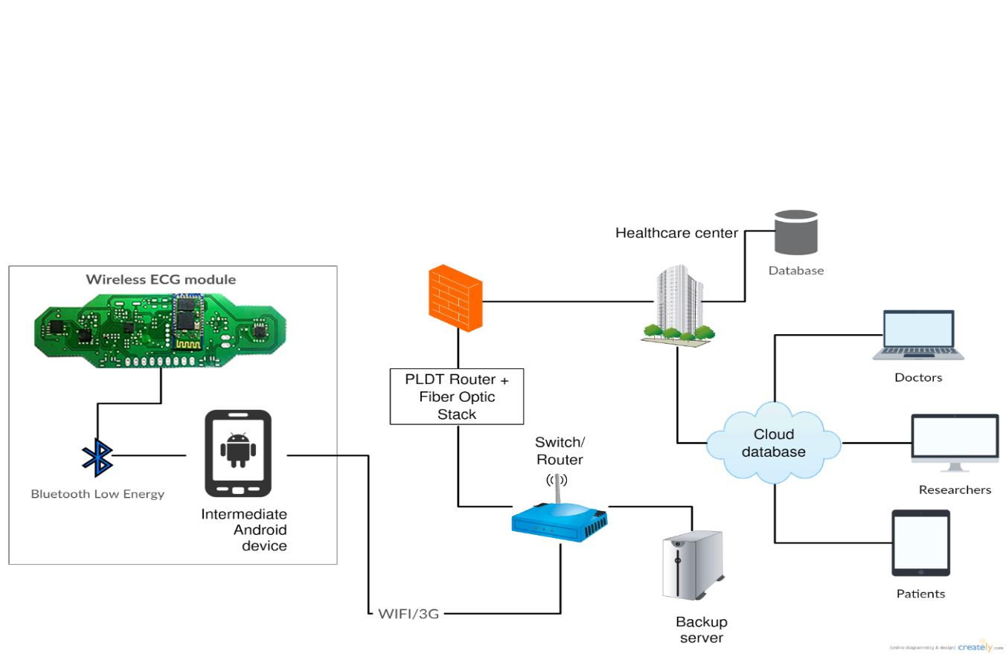

**Figure 5.** The complete system of our wireless and portable ECG monitoring device

CASSANDRA presents a system for measurement, data transfer and analysis following with doctor’s assessment of the ECG signal in the long run over the Internet. The system includes a compact receiver chip allows a patient-worn 24/7 without causing too much trouble for everyday life. This device can acquire the ECG signal in real time on 4 crucial leads, including 3 limb leads (I, II, III) and 1 chest leads (V1). Moreover, the received signal will be transmitted to patient’s smartphone via Bluetooth 4.0, therefore the final product would be very maneuverable and patients can self-assess their health status while at home. Finally, the signal will be sent from smartphone to our dedicated server, where our software is implemented, for data pre-processing and rhythm analysis that help doctors make the fast and reliable diagnosis. Final prescription and healthcare advice will then be given to the patient via in-app communication services (chat and video call). In case of vital situations, the doctor can make an emergency call to nearby hospitals, alarming both the patients and their relatives to perform first aid if necessary.

**⮚ Development process**

In this part, we will describe our plan to accomplish both the final product and business model. We will describe in detail about what we have already accomplished and give general ideas about the future development.

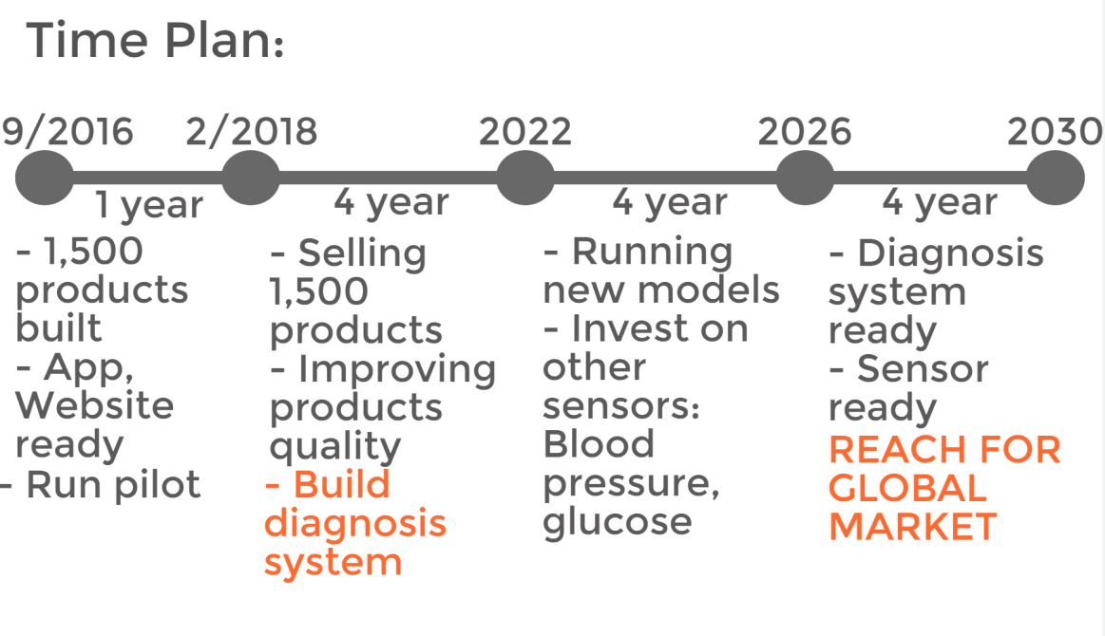

**Figure 6.** The project timeline

1. **The first year plan (from 9/2016 to 2/2018)**
2. **Hardware design and prototype development details**

* *Status*: prototype accomplished, continue to improve
* *Development time*: 1.5 year (from September 2016 to February 2018)
* *Function*: 4 leads of ECG signal obtained during each calibration, real-time ECG data transmission via Bluetooth 4.0 Low Energy, sensor’s sampling rate of 160Hz, battery life up to 48 hours of continuous measuring
* *Further improvement*: working on industrial design, improving signal quality and investigating on other types of sensors
* *List of purchased hardware:*

|  |  |  |  |  |  |
| --- | --- | --- | --- | --- | --- |
| **No.** | **Name** | **Product code** | **Num.** | **Price (USD)** | **Total (VND)** |
| 1 | CONN HEADER 10POS DUAL .05" SMD | FTSH-105-01-L-DV | 10 | 41.87 | 1,395,652.71 |
| 2 | CONN HEADER 2POS .100" SGL GOLD | TSW-102-07-G-S | 10 | 10.84 | 361,329.72 |
| 3 | CONN HEADER 3POS 1.25MM R/A TIN | 530480310 | 10 | 6.25 | 208,331.25 |
| 4 | SWITCH TACTILE SPST-NO 0.05A 12V | PTS635SL50LFS | 20 | 11.04 | 367,996.32 |
| 5 | CAP CER 0.1UF 25V X7R 0603 | 478-3713-1-ND | 40 | 9.744 | 324,796.75 |
| 6 | CAP CER 1UF 16V X5R 0805 | 478-1411-1-ND | 10 | 2.52 | 83,999.16 |
| 7 | CAP CER 1000PF 100V C0G 0603 | 445-2312-1-ND | 10 | 1.14 | 37,999.62 |
| 8 | CAP CER 22PF 50V NP0 0603 | 478-1167-1-ND | 20 | 0.76 | 25,333.08 |
| 9 | CAP CER 1PF 50V NP0 0402 | 490-3199-1-ND | 20 | 0.42 | 13,999.86 |
| 10 | CAP CER 0.4PF 50V NP0 0402 | 490-11410-1-ND | 10 | 1 | 33,333.00 |
| 11 | CAP CER 18PF 50V NP0 0402 | 490-5858-1-ND | 20 | 0.34 | 11,333.22 |
| 12 | CAP CER 15PF 50V NP0 0402 | 490-5888-1-ND | 20 | 0.34 | 11,333.22 |
| 13 | CAP CER 12PF 50V NP0 0402 | 490-5924-1-ND | 20 | 0.36 | 11,999.88 |
| 14 | CAP CER 1000PF 50V NP0 0402 | 490-3244-1-ND | 10 | 0.55 | 18,333.15 |
| 15 | CAP CER 0.1UF 10V X7R 0402 | 490-6321-1-ND | 60 | 0.564 | 18,799.81 |
| 16 | CAP CER 47UF 6.3V X5R 1206 | 490-6508-1-ND | 10 | 5.44 | 181,331.52 |
| 17 | CAP CER 10UF 6.3V X5R 0603 | 490-3896-1-ND | 20 | 2.96 | 98,665.68 |
| 18 | CAP CER 220PF 50V NP0 0402 | 490-1293-1-ND | 10 | 0.27 | 8,999.91 |
| 19 | LED YELLOW CLEAR 0402 SMD | 511-1595-1-ND | 10 | 5.02 | 167,331.66 |
| 20 | FERRITE BEAD 1 KOHM 0402 1LN | 490-3999-1-ND | 10 | 2.64 | 87,999.12 |
| 21 | FIXED IND 2.2NH 300MA 120 MOHM | 490-2614-1-ND | 10 | 0.83 | 27,666.39 |
| 22 | FIXED IND 5.1NH 300MA 200 MOHM | 490-11668-1-ND | 10 | 2.47 | 82,332.51 |
| 23 | FIXED IND 2NH 300MA 100 MOHM SMD | 490-6569-1-ND | 20 | 1.56 | 51,999.48 |
| 24 | RES SMD 1M OHM 5% 1/16W 0402 | 541-1.0MJCT-ND | 40 | 0.96 | 31,999.68 |
| 25 | RES SMD 51 OHM 5% 1/16W 0402 | 541-51JCT-ND | 20 | 0.66 | 21,999.78 |
| 26 | RES SMD 0.0OHM JUMPER 1/16W 0402 | 541-0.0JCT-ND | 210 | 2.877 | 95,899.04 |
| 27 | RES SMD 2.74K OHM 1% 1/16W 0402 | 541-2.74KLCT-ND | 10 | 0.48 | 15,999.84 |
| 28 | RES SMD 2M OHM 1% 1/16W 0402 | 541-2.00MLCT-ND | 10 | 0.48 | 15,999.84 |
| 29 | RES SMD 10K OHM 5% 1/16W 0402 | 541-10KJCT-ND | 10 | 0.33 | 10,999.89 |
| 30 | RES SMD 1M OHM 1% 1/16W 0402 | 541-1.00MLCT-ND | 10 | 0.48 | 15,999.84 |
| 31 | RES SMD 200K OHM 1% 1/16W 0402 | 541-200KLCT-ND | 10 | 0.48 | 15,999.84 |
| 32 | RES SMD 10M OHM 1% 1/16W 0402 | 541-10.0MLCT-ND | 10 | 0.48 | 15,999.84 |
| 33 | RES SMD 3.01M OHM 1% 1/16W 0402 | 541-3.01MLCT-ND | 10 | 0.48 | 15,999.84 |
| 34 | RES SMD 56.2K OHM 1% 1/16W 0402 | 541-56.2KLCT-ND | 10 | 0.48 | 15,999.84 |
| 35 | RES SMD 2.21K OHM 1% 1/16W 0402 | 541-2.21KLCT-ND | 10 | 0.48 | 15,999.84 |
| 36 | CRYSTAL 32.7680KHZ 9PF SMD | 535-9544-1-ND | 10 | 9.69 | 322,996.77 |
| 37 | CRYSTAL 4.0960MHZ 18PF SMD | XC1680CT-ND | 10 | 9.1 | 303,330.30 |
| 38 | DIODE SBR 20V 200MA SOD523 | SBR0220T5-7DICT-ND | 10 | 4.27 | 142,331.91 |
| 39 | IC AFE 24BIT 25.6KSPS 28WQFN | 296-35511-1-ND | 10 | 160.2 | 5,339,946.60 |
| 40 | IC REG BST ADJ 0.2A SYNC SC70-6 | 296-32505-1-ND | 10 | 14.7 | 489,995.10 |
| 41 | IC AFE HEART MONITOR 20LFCSP | AD8232ACPZ-R7CT-ND | 10 | 45.91 | 1,530,318.03 |
| 42 | BLE Module | HM-10 | 10 | 80 | 2,666,640.00 |
| 43 | 10 Positions Header | FTSH-105-01-L-DV | 10 | 40.00 | 1,333,320.00 |
| 44 | Electrode cable |  | 10 | 30.00 | 999,990.00 |
| 45 | Electrode |  | 10 | 40.00 | 1,333,320.00 |
| 46 | ECG Gel |  | 10 | 15.00 | 499,995.00 |
| 47 | Board printing |  | 15 | 3.00 | 1,500,000.00 |
| **TOTAL EXPENSE** | **20,382,000 VND** | | | | |

* *Product detail*: Not so much difference from the original version, we renovated the design so that it becomes a compact, flexible and convenient wearable that allows 24/7 patient-worn.

ECG circuitry was designed from the hard PCB circuit. We started developing a signal pre-processing board (figure 2.1) following a round design pattern with a diameter of 6 cm and thickness of 0.8mm. It was made rounded to avoid injury to the user compared to the cornered version. Besides, round-shaped makes the circuit more beautiful and match with some popular ones in the market.

Thickness is selected to match the safety criteria but also has to be compact, not brittle and must be able to sustain high mechanical strength. The central part is equipped with 1 electrode of 1.54 cm diameter and a 4.0 type button. This central board is designed to function as a right-hand electrode so that the circuit is placed on the patient's right corner. In addition to electrodes placed in the center, there are other 4-wire electrodes located in the border circuits. These wires correspond to the limb electrodes: left arm (LA), left leg (LL), right leg (RL) and chest (V1). The current version of the device is a complete, flexible circuit and the future design will be using the biological material with electrodes and electronic components attached directly to the circuit.

The device consists of three main parts: the circuit which serves as a buffer and signal amplification; a Low Energy Bluetooth communication circuit and a battery. The completed device can be programmed with sampling frequency ranging from 20Hz to 1000Hz according to user’s needs. Moreover, the device is also capable of sampling with high-resolution 24bits.

Working principle of the device, to be brief, is measuring the electrical current of the 3 limb leads. Then Wilson Central is calculated by taking the average of these three and the final result is then packaged and served to others devices via BLE.

1. **Mobile application and doctor website development**

* *Status*: prototype accomplished, core function finished and continue to develop
* *Development time*: 12 months (from May 2016 to May 2017)
* *Function*: App receives data from BLE, plot the signal, stream data to server, it’s user experience improved and doctor website received data in real-time
* *Further improvement*: integrate with alarming system, communication protocols (chat and video call) and electronic health records, prescription and doctor’s advice for both the app and doctor website
* *List of hardware*:

|  |  |  |  |  |  |
| --- | --- | --- | --- | --- | --- |
| **No.** | **Name** | **Company** | **Num.** | **Price (USD)** | **Total (VND)** |
| 1 | Server, hosting | MatBao company | 1 | 149 | 3,425,122 |
| 2 | User experience design | Atoz company | 1 | 599 | 12,682,398 |

* *Product detail:*

About the software, we include a mobile app that allows patients to self-monitor and stream ECG data and a website for a physician to evaluation which is the highlight of the project. For this reason, our project meets the requirements of novelty and utility solutions for the community.

Our software includes 2 parts: the connection between the ECG device and Android smartphones via Bluetooth Low Energy protocol (BLE) and data transfer protocol between smartphones and doctor website via the Internet.

BLE is used for efficiency and energy saving. By comparison, the method for transferring ECG data via BLE not only ensures real-time streaming but also reduces energy consumption for more than 8 times compared to traditional protocol Bluetooth (Bluetooth 2.0). Signal transmission distance is optimal within 10m and this is consistent with the objectives of the subject. The first version of the program is written on the Android operating system in JAVA using Android Studio. The second version, which is also stable and more flexible for multiple platforms development, is written in Ionic and ngCordova plugins. The result on both versions is acceptable and the real-time data transfer via BLE accomplishes a delayed time of no more than 300ms.

Once the signal is received on the phone, a parallel program is conducted for the purpose of sending a message to the server. This program initiates a connection to the server using web sockets. After the connection is established, the signal is transmitted directly from the phone to the server through the TCP/IP protocol. Tests show that signals on both Wifi and 3G are transmitted smoothly with trivial time delay. However, the transmission becomes unresponsive when performed with weak internet connection running on weak personal computers. Therefore, it is important that doctors should be equipped with strong computational PC as well as decent internet connection.

1. **Business model and intellectual properties registration**

* *Status*: in process
* *Development time*: 7 months (from October 2016 to May 2017)
* *Function*: business plan and intellectual properties documented
* *Further improvement*: finish the registration of intellectual properties before May 2017, doing intense market research to fit our devices to Vietnam market.

1. **IT infrastructure and database development**

* *Status*: not started yet
* *Development* *time*: estimate 4 months (from May 2017 to September 2017)
* *Our plan*: hiring third-party companies, such as FPT Software, to build the foundation for our IT infrastructure that could handle thousands of connection simultaneously, working with scientists, researchers and database specialists to structure the database system so that it ensures fast data exchange and high maneuverability.

1. **The four years plan (from 2018 to 2022)**
2. **Pilot and implementation**

* Status: not started yet
* Development time: 1 year after the first year plan (from September 2017 to September 2018)
* Our plan: after finishing the industrial prototype, we try to contact international companies and clinics and ask for permission to pilot the device. The reason why we choose large and international companies is that they put great effort to make their workplace a safe place to work for their employees. This will make it easier for us to ask for medical product implementation. Moreover, we have good social networks with many private doctors and clinics, so the process of introducing the device to the community is also possible.

1. **Heart disease detection algorithm - development protocol**

* *Status*: long-term development strategy
* *Development time*: 2 years after product’s pilot
* *Our plan for research activities:*

*Step 1: Specifying the appropriate database for training the model*

Firstly, an extensive effort will be made to specify which ECG database on PHYSIONET will be cultured. The data selected to train the model must contain the real-time measurement of ECG signals for a particularly long period of time (from 24 to 48 hours) even before an acute chest pain happens. Together with this criteria, the final medical condition of the subjects must also be documented: the occurrence of heart attack and mortality rate.

*Step 2: Finding the common ECG patterns and applying weighting factors*

In this step, the transaction phase when normal ECG slowly develop into an acute phase is investigated. Common patterns must be seen across several patients when the normal ECG develops into abnormal one that signifies the early presence of acute heart attack. In addition, a weighting factor is applied to these patterns, representing the likely hood that whether or not this pattern is a manifestation of cardiovascular problems. After performing calculation and projection, the underlying features is announced.

*Step 3: Developing the algorithm and the prediction model*

At this stage, non–linear mathematical and statistical analysis is applied to create the forecasting model of cardiovascular disease. This model combines information derived from the previous stage and presents them as a system of non–linear differential equation for long term or short term prediction of CAD.

*Step 4: Validating the accuracy of the algorithm using other sources of data*

This step involves the process of comparing the result obtained by the model’s algorithm with the actual documented cases. The sensitivity of the model is then recorded and further improvement is applied if necessary.